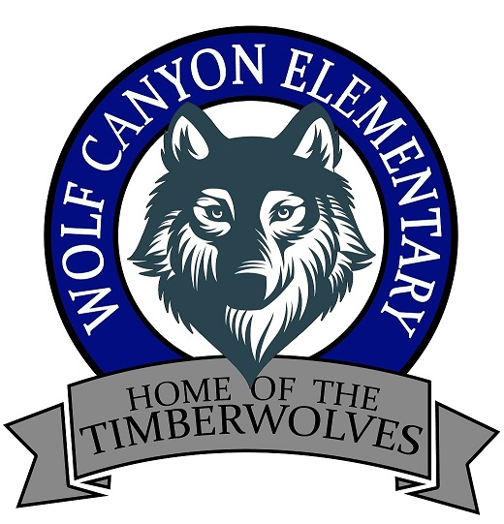

Calling all Military Parents and
Students!

In honor of Month of the Military Child
You’re invited to the Wolf Canyon
Family Military Munch, Mingle, and Play!

Thursday, April 5, 2018
6:00-7:30 p.m.
Wolf Canyon Auditorium

Dinner will be provided. Please bring a board game to share with others

Feel free to bring cookies and copies of the recipe for a Cookie Exchange!

Please RSVP by Thursday, March 15 by returning this form to the school office or emailing lisa.lines@cvesd.org
----------------------------------------------------------------------------------------------
I plan to attend the Military Support Committee meeting at Wolf Canyon Elem. on April 5, at 6:00 p.m.

Parent’s Name________________________________
Child’s Name_________________________________
Child’s teacher_______________________________
Number attending__________

