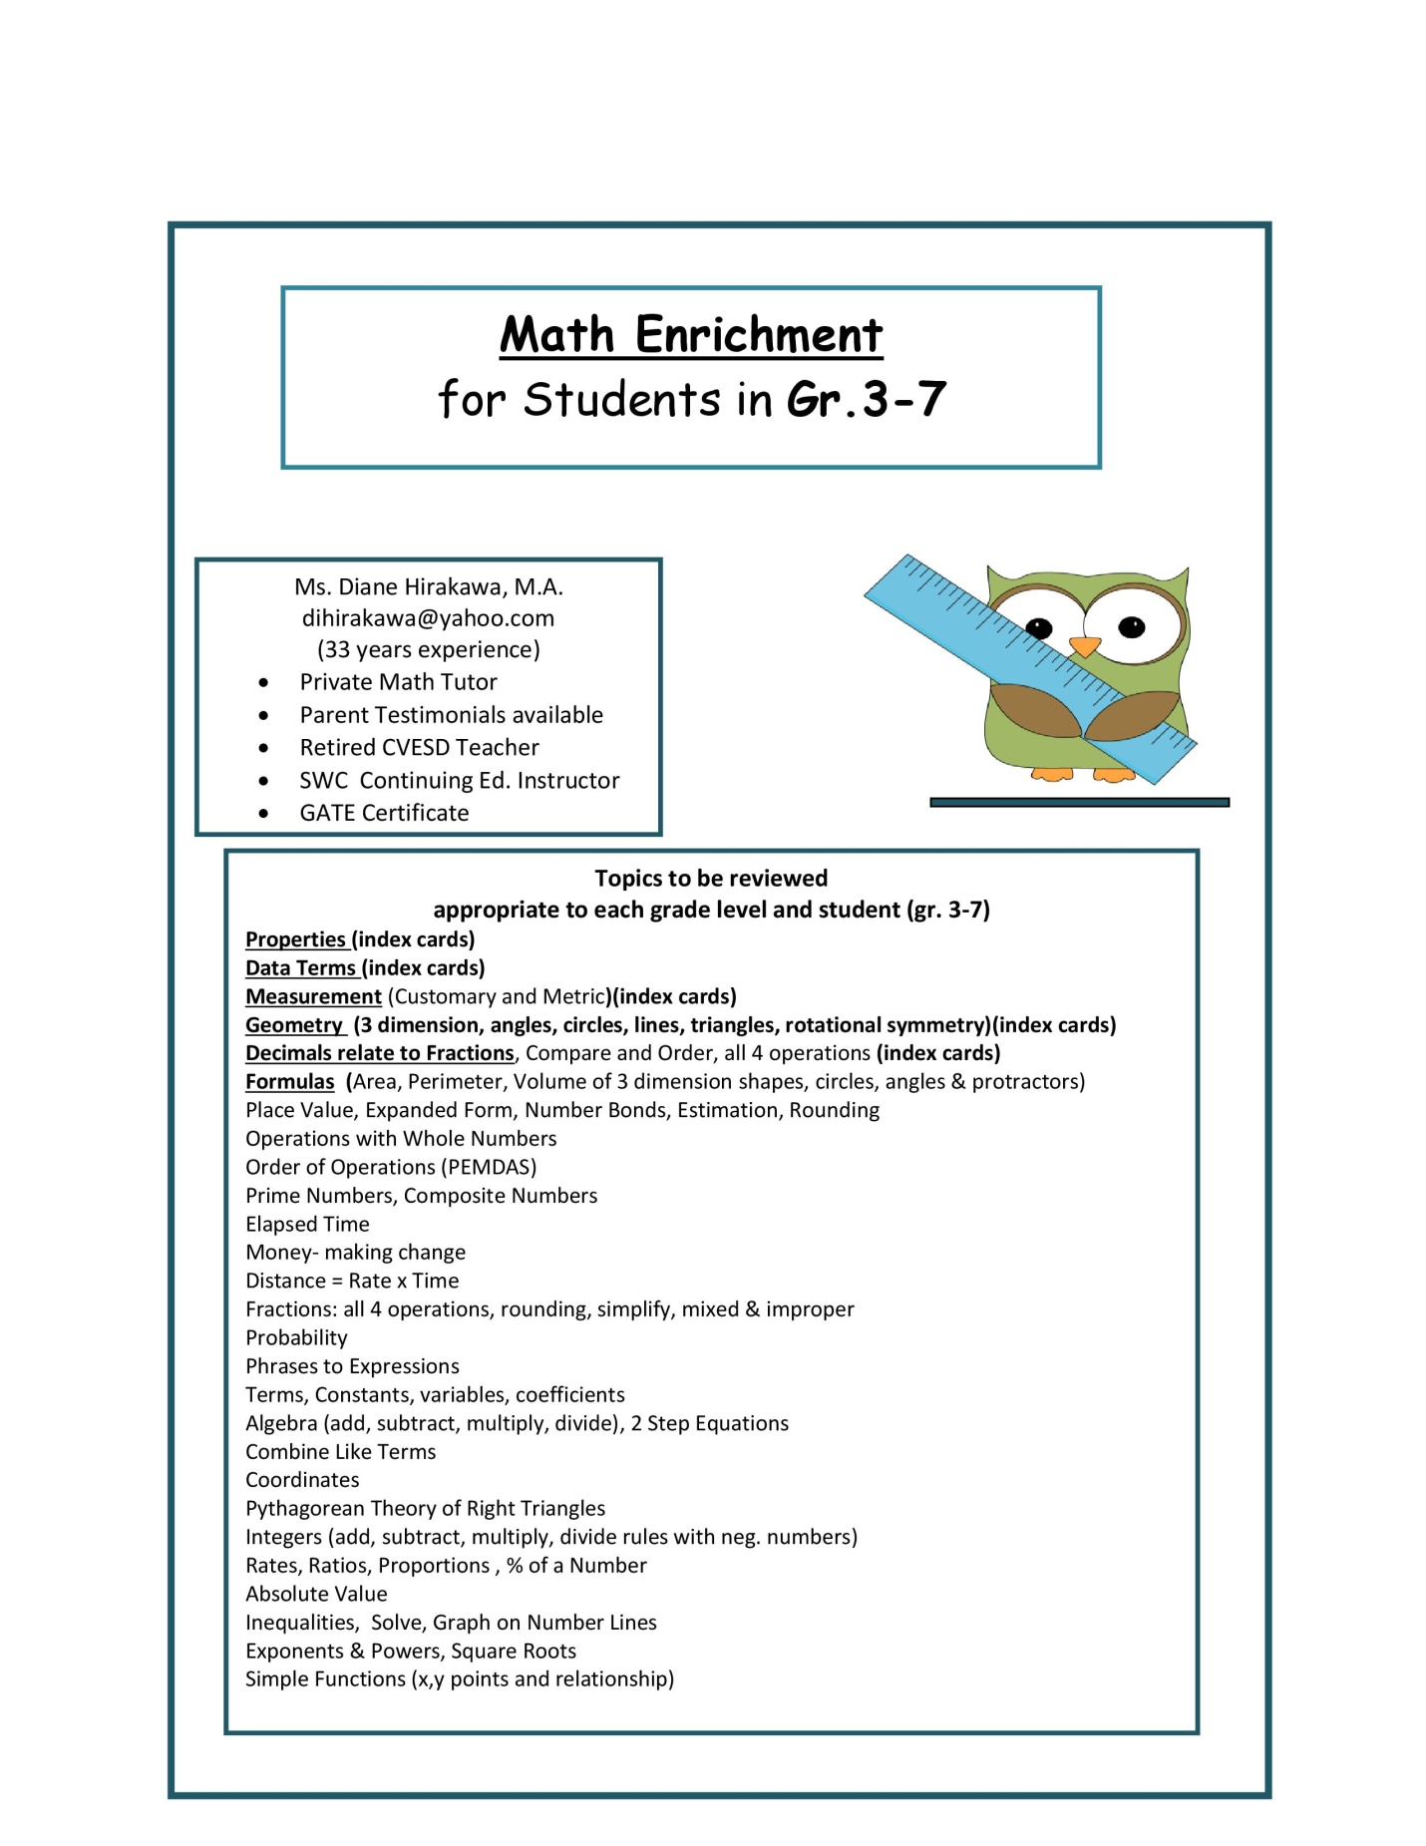
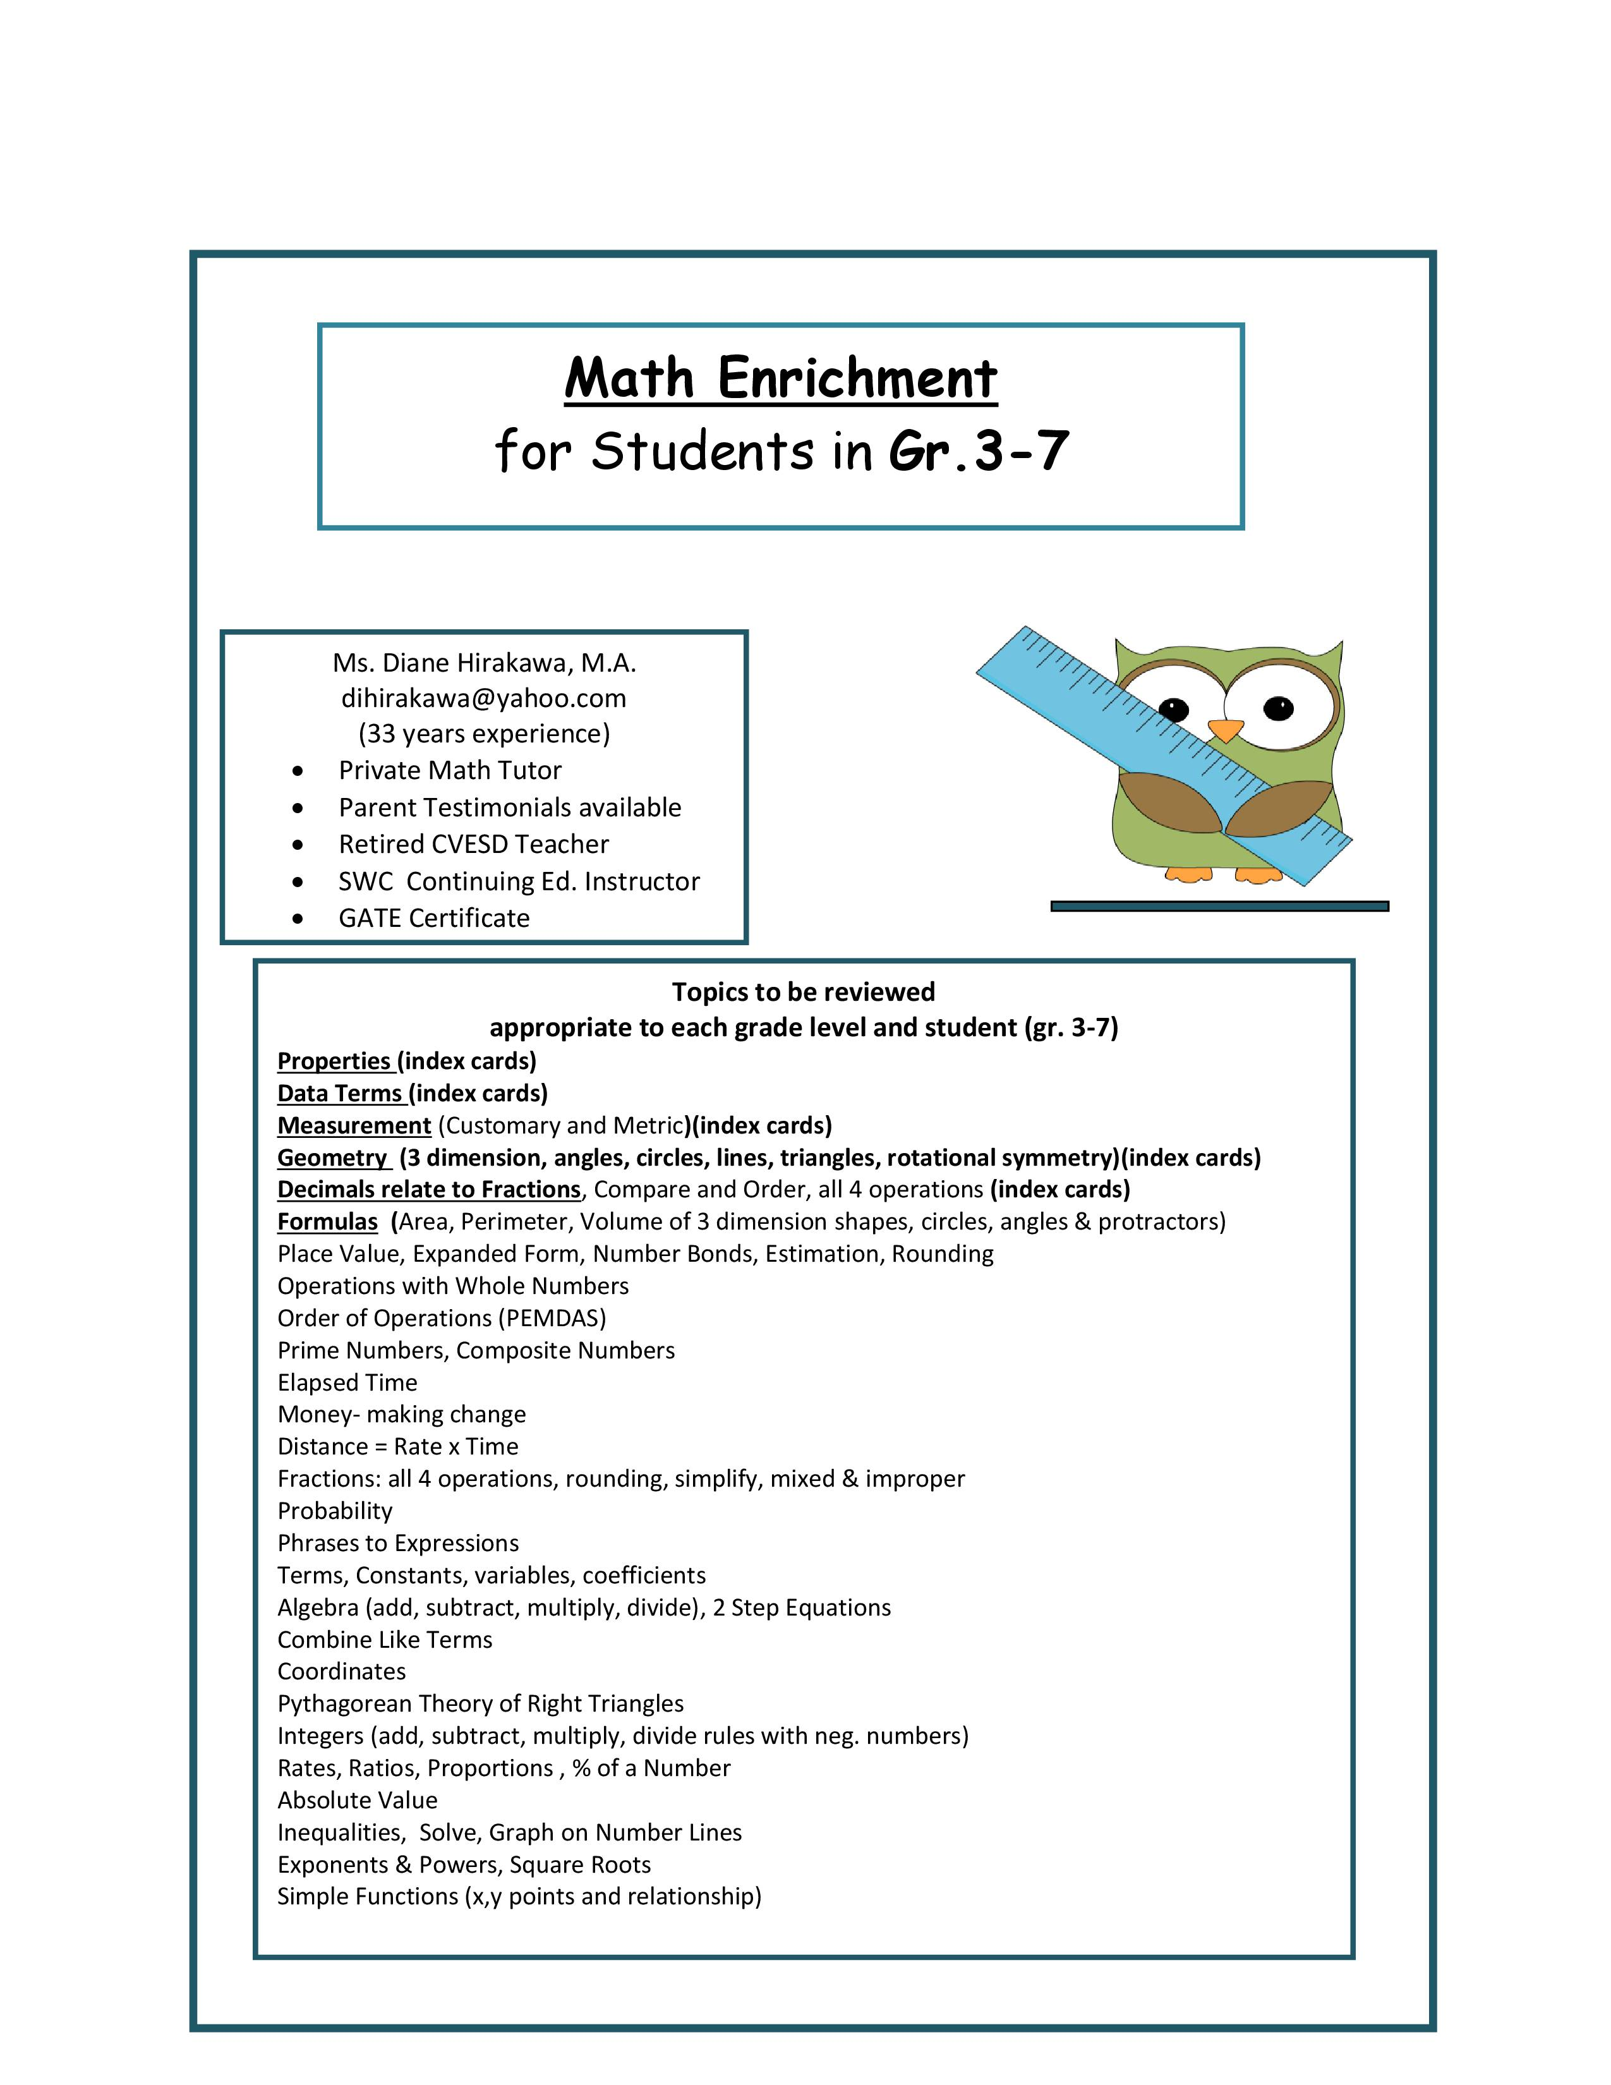
SUMMER MATH 4 SESSION REVIEW
June and July

Review of Current Grade Level
Preview of Next Grade Level
Main Math Concepts

Contact: Diane Hirakawa, M.A.
dihirakawa@yahoo.com

